

Game Design Document



Table of Contents

1. Overview **3**

1.1. Genre and Target Platform 3

1.2. Inspiration 3

1.3. Setting 5

1.4. Goals / Player experience 5

2. Gameplay **6**

2.1. Description 6

2.2. Mechanics 6

2.2.1. Movement & Interact 6

2.2.2. Weight & Balance 6

2.2.3. Objective 6

2.2.4. Weight Modifiers 7

2.2.5. Buttons 7

2.2.6. Weighted Boxes 8

2.3. Camera 8

2.4 Menus + state flow 8

2.4.1 Main Menu 10

2.4.2 Game screen 10

2.4.3 Level Select Menu 11

2.4.4 Pause Menu 11

2.4.5 Level Failed Menu 13

2.4.6 Level Complete Menu 14

2.5 Levels 15

2.5.1 Level 1 - Tutorial 15

2.5.2 Level 2 - Button Basics 16

2.5.3 Level 3 - Weight Modifier Basics 17

2.5.4 Level 4 - Weighted Boxes Basics 18

2.6 Server Blueprint 19

3. Presentation **20**

3.1. Art style & Assets 20

3.2. Game UI 21

3.3. Computer Graphics 22

3.3.1. Lighting 22

3.3.2. Particle effects 22

3.3.3. Shaders 23

3.4. Audio 24

3.4.1. Music 24

3.4.2. Sound effects 24

# 1. Overview

## 1.1. Genre and Target Platform

Tilted is a multiplayer **co-op puzzle** game for Windows PC. It is created using Unreal Engine version 4.27.

## 

## 1.2. Inspiration

Tilted’s gameplay draws inspiration from the complex rotating stages seen in the **Super Monkey Ball** series, as well as the balance mechanics present in the “**Balance Boat**” and “**Tippy Traverse**” minigames from Wii Party. Additionally, the game’s visual style and futuristic aesthetic is heavily inspired by the movie **Tron: Legacy**.

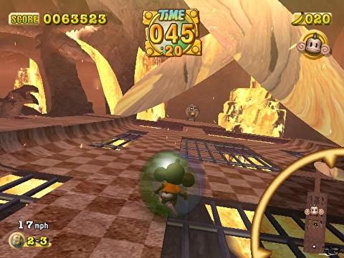

Super Monkey Ball 2

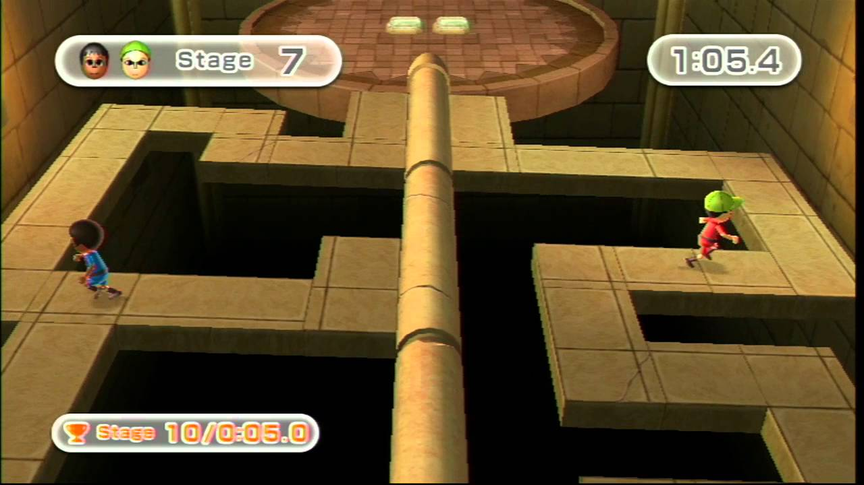

“Tippy Traverse” from Wii Party

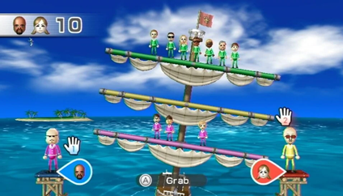

“Balance Boat” from Wii Party



Tron: Legacy

## 1.3. Setting

Tilted is a simple game with a focus on its gameplay. It’s not set in any tangible world or universe, as much as it simply exists within its own gameplay bubble. The game does not require any lore or story to be enjoyable or understandable, as creating one would not improve the experience in any way, and would in fact only serve as a possible way to cause confusion or uninterest in the player.

Despite not having a story, the game world where Tilted takes place still has a distinct visual setting. It has a futuristic aesthetic, with an abundance of black accompanied by bright, colourful neon lights, similar to something you would find in the Tron universe.

## 1.4. Goals / Player experience

Our game aims to give the player a simple, fun experience to share with a friend. We want to provide players with challenges that require them to analyse each level and think about how to beat it (and the subsequent feeling of accomplishment when they do), while not making it too complex or hard to understand as to avoid frustration. Similarly, we expect our players to have basic control of the movement of their character, while not making it very mechanically demanding to do so.

# 

# 2. Gameplay

## 2.1. Description

Tilted is a co-op game where the players are dropped into a floating platform that tilts according to their weight distribution. This means that both players must work together to meticulously traverse the platform in such a way that it doesn’t tilt too much and drops them to their deaths.

Each player has a colour coded goal assigned to them that they must reach. Each level is completed when both players are standing in their respective goals.

## 2.2. Mechanics

### 2.2.1. Movement & Interact

The player can move by using the WASD keys and interact with certain objects by pressing the “E” key. The player has a consistent speed of 600.

### 2.2.2. Weight & Balance

Each player and certain other objects have weight, which influences the inclination of the stage’s platform(s). The platform has a centre of gravity, meaning that the further away a player is from that centre, the more force their weight applies to the platform. The platform can be tilted on the X and Z axis. If the platform tilts too much, the players are no longer able to stand on it and will slide off to their deaths.

### 2.2.3. Objective

Each player has an assigned color-coded goal that matches their character’s color that they must reach in order to complete a level (Player 1 is blue and Player 2 is red). This goal is always highlighted to the player, and consists of a small circular area with a flag in the middle. However, even if a player has reached their assigned goal, they are still prone to falling off the stage and losing the level until their partner also reaches their goal. When both players are standing in their respective goals, the level is officially complete.

### 2.2.4. Weight Modifiers

These pick-up items appear on the map as soon as the level starts, and are used to alter the weight of the player who picked them up. A player' weight is changed automatically when they collide with the object, and will remain changed until the end of the level or until they pick up another weight modifier. When a player’s weight is changed, the size of his player character changes accordingly (a lighter weight makes the character smaller and a heavier weight makes it bigger). When a weight modifier is picked up, it does not respawn (unless the level is restarted). The use of these items is often required to complete a level, but this doesn’t necessarily mean players should pick up every modifier they see, as there can also be “red herring” items that can potentially influence the balance of the level in a negative way if they are collected. It is up to the players to analyse the layout of the level and figure out how to utilise these to their advantage. 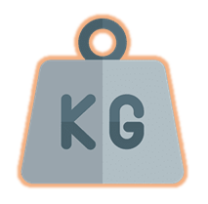There are 3 types of weight modifiers:

1. **Heavyweight** - Drastically increases the player’s weight (3x default).



1. **Lightweight** - Drastically decreases the player’s weight. (0.4x default)



1. **Reset weight** - Resets the player’s weight to its default value.

### 2.2.5. Buttons

Buttons can be used to open (and sometimes close) certain paths in the level. Each Button is connected to up to 2 barriers. This connection is represented by a distinct neon light that links these entities together, much like a cable would. Buttons can be activated by getting next to them and pressing the interact key (E). When a Button is activated, it immediately switches the power of the barriers connected to it. If a Button is only connected to a single barrier, players only need to activate it once in order to disable it. However, if a Button is connected to 2 barriers at once, it means that activating it will disable one barrier, but enable another, meaning players might need to activate it more than once in order to complete the level.

### 

Button

### 2.2.6. Weighted Boxes

Much like the player character, these boxes have an assigned weight class that can influence the balance of the stage platform. A player can move one of these boxes by walking directly against it, pushing it in that direction. The weight class of the box is represented by the icons shown below.

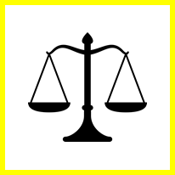

## 

## 

## 

**Heavyweight box**  **Default weight box**   **Lightweight box**

(3x default player weight) (same as default player weight) (0.4x default player weight)

## 2.3. Camera

The camera is **third person** (FOV 90º). It follows the player character as it moves through the platform and allows decent visibility in all directions (except the back) around the character. The player can also move the camera using the mouse. Moving the camera also rotates the player character in such a way that the camera is always facing the character’s back.

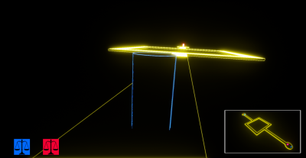

## 2.4 Menus + state flow

The game’s menus can be navigated as shown in the graph below.

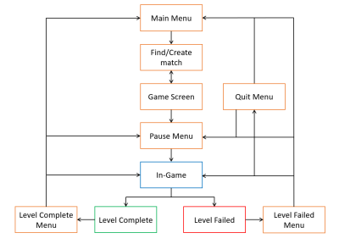

### 

### 2.4.1 Main Menu

The main menu includes the “**Play**” button, the “**Instructions**” button, the “**Options**” button and the “**Quit**” button.

“**Play**” has two embedded options when it is clicked. One is “**Create Lobby**”, which instantiates a new game session and leads the player to **Level 1**. The other option is “**Join Lobby**”, which leads them to the **level in which that session is being held at.**

“**Options**” allows the player to change certain settings, such as game volume, key bindings and camera sensitivity.

“**Instructions**” allows the player to learn about the game and how it is played.

“**Quit**” exits the game.

### 

### 2.4.2 Game screen

After the first player creates the lobby from the main menu, they are led to this screen, which shows a randomly generated session code that a second player can use to join the session. After both players successfully connect to the server, the game starts. The players can press **P** to open the “pause” menu and change settings in the embedded **Options** menu, as well as leave at any point, with the **Quit** button, which will bring them back to the main menu. In the event that one player disconnects in the middle of an on-going game, the other one is automatically sent back to the main menu.

### 2.4.3 Level Select Menu

This menu shows all the levels in the game, and allows the **player** to select a level.

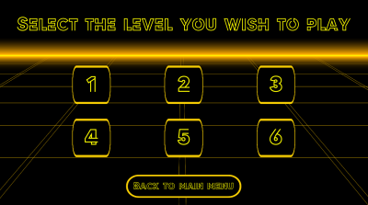

### 2.4.4 Pause Menu

In the middle of the game, a player can press the “Esc” key to open the Pause Menu. This pauses the game for both players. This menu includes the “**Resume**” button, the “**Level Select**” button, the “**Main Menu**” button and the “**Quit**” button.

The “**Level Select**” option, if the player selects this option, they are prompted to a choice of levels, and, upon selecting a level, they are prompted to that level. The other player is moved back into the main menu.

“**Resume**” closes the pause menu and allows the players to continue playing.

“**Main Menu**” exits the match and brings both players back to the main menu.

“**Quit**” exits the game. The other player is automatically sent back to the main menu.

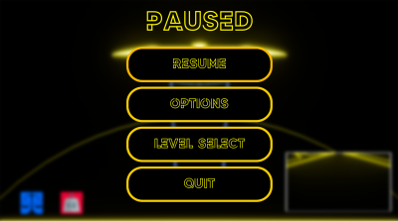

### 

### 2.4.5 Level Failed Menu

If any of the players falls off the stage, both players are shown the Level Failed Menu, which includes the “**Retry**” button, the “**Level Select**” button, the “**Main Menu**” button and the “**Quit**” button.

The “**Retry**” option sends the player back to the start of the level. The other player is sent to the main menu.

The “**Level Select**” option, if the player selects this option, they are prompted to a choice of levels, and, upon selecting a level, they are prompted to that level. The other player is moved back into the main menu.

“**Main Menu**” exits the match and brings both players back to the main menu.

“**Quit**” exits the game. The other player is automatically sent back to the main menu.

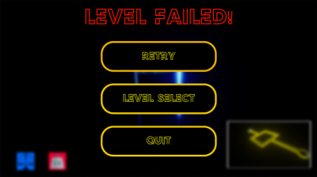

### 

### 2.4.6 Level Complete Menu

If both players are simultaneously in their respective goals, they are shown the Level Complete Menu, which includes the “**Next Level**” button, the “**Level Select**” button, the “**Main Menu**” button and the “**Quit**” button.

The “**Next Level'' option**, if the player selects this option, they are sent to the next level, where they will be waiting for a second player. The other player is sent to the main menu.

The “**Level Select**” option, if the player selects this option, they are prompted to a choice of levels, and, upon selecting a level, they are prompted to that level. The other player is moved back into the main menu.

“**Main Menu**” exits the match and brings both players back to the main menu.

“**Quit**” exits the game. The other player is automatically sent back to the main menu.

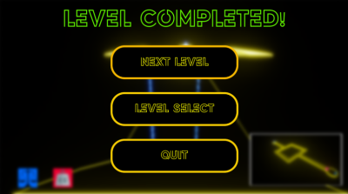

## 

## 2.5 Levels

Tilted has 4 unique levels, each representing the mechanics of the game, getting more complex the higher the level.

### 

### 2.5.1 Level 1 - Tutorial

The first level is very simple, meant to convey the main mechanic of balancing the platform to the players, while not overwhelming them with complex routes or items.

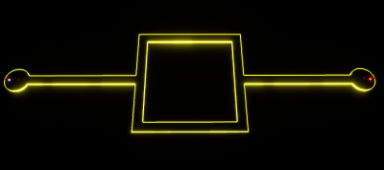

In order to complete this level, the players must essentially reach each other’s spawn positions. All they need to do is walk forward at the same rate, in such a way that doesn’t tile the platform too much in either direction. After they reach the middle square section, they need to go to the opposite side from each other (if player 1 goes to their right, player 2 should also go to their right, as it is the other player’s left), so that their weights counterbalance each other. If both players advance at a consistent, steady pace, they should have no trouble reaching their respective goals.

### 

### 

### 2.5.2 Level 2 - Button Basics

This level is a simple introduction to the Button mechanic. Since it’s the first time players will see a Button in the game, this level is still pretty simple and straightforward.

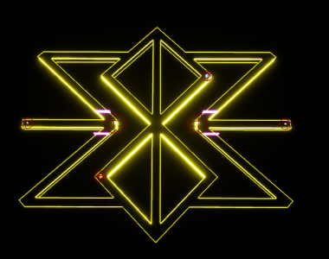

In order to complete this level, players must go around the cross on opposite sides (similar to how they did in the first level). Along the way, they will find some barriers blocking the path. However, on the other side, the other players should see a Button that can deactivate those barriers. This way, both players can progress along, clearing each other’s paths until they reach their objectives.

### 2.5.3 Level 3 - Weight Modifier Basics

This level is a simple introduction to the weight modifier mechanic. Now that the players understand how to properly balance the stage by working together, they must learn about different weight types and how to use them in order to achieve victory.

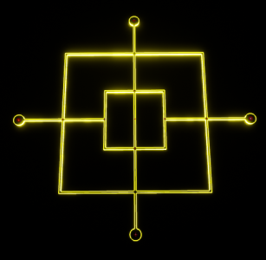

In order to complete the level, both players should walk towards the heavyweight modifier at the centre. At this point, **it’s crucial that Player 1** (blue) **picks up the heavyweight modifier**. Otherwise, players won't be able to reach their assigned objectives without tilting the stage too much. Regardless, after one player picks up the modifier, both players have ample space to walk around and test how the different weights affect the balance of the stage. If Player 1 picks up the modifier, both players just need to walk to their objectives. Since Player 1’s objective is closer to the stage’s centre of gravity, it counteracts the fact that Player 1 is heavier.

## 

### 2.5.4 Level 4 - Weighted Boxes Basics

This level is a simple introduction to the weighted boxes mechanic. This level’s layout is very similar to the previous one, so players should be able to figure out the solution very intuitively.

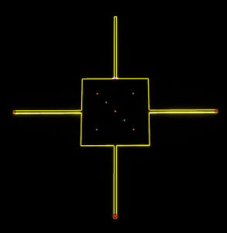

In order to complete this level, players must push the weighted box at the centre as far away from the flags as possible. Since one player is pushing the box, the other player needs to counteract the balance of the platform with his own weight, otherwise the platform will tilt too much to one side. After the box is placed far enough, both players can reach their objectives, which are right next to each other.

### 2.6 Server Blueprint

The game’s **connectivity systems** function like in the graph shown below.

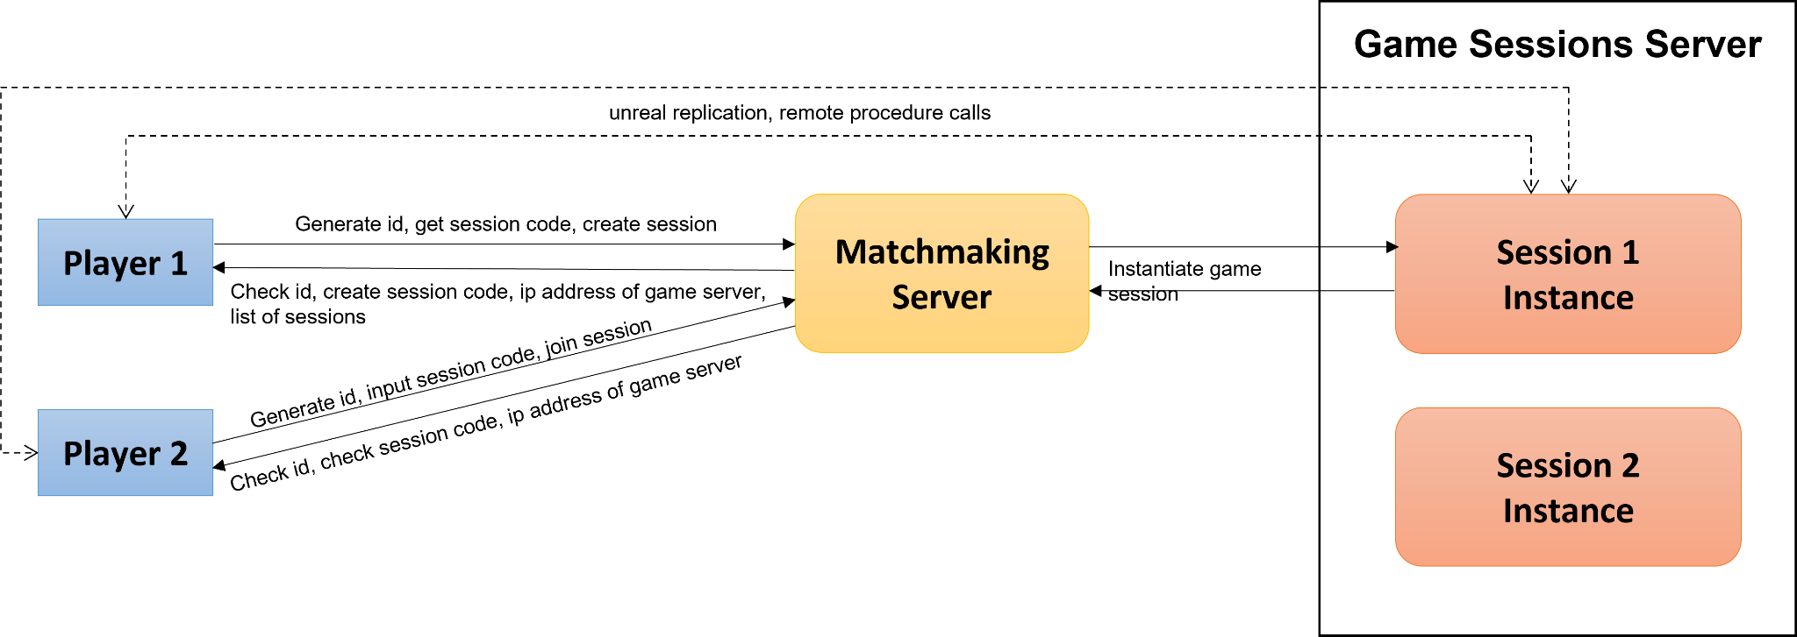

The first player creates a session with a unique session code generated by the matchmaking server. The second player can then join this session by inputting the proper session code.

# 3. Presentation

## 3.1. Art style & Assets

Tilted’s visual style shares a heavy resemblance to Tron: Legacy, boasting bright neon lights and a futuristic aesthetic. Player characters consist of humanoids in a neon light suit, and are identical to each other, only differing in color (Player 1 is blue and Player 2 is red). All other objects in the game, from gameplay objects to the simple stage layout, share this visual style of black cores with neon light outlines. The background environment also consists of a void-like darkness covered in a neon light grid.

## 

## 

## 3.2. Game UI

Tilted’s UI has 2 main elements: the **Weight Class**, displayed on the bottom left corner, and the **Level Weight Distribution Panel**, displayed on the bottom right corner. The Weight Class shows the current weight class (lightweight, default or heavyweight) of both players, in case the size of the characters is not a clear enough identifier. The Level Weight Distribution Panel shows how the weight is being distributed across all entities (players and boxes). The red dot represents the center of gravity of the stage, and it needs to be around the middle of the crosshair for it to be balanced and stable. If the red dot is shifting too much in one direction, players should make an effort to apply more weight in the opposite direction, in order to balance the stage out.

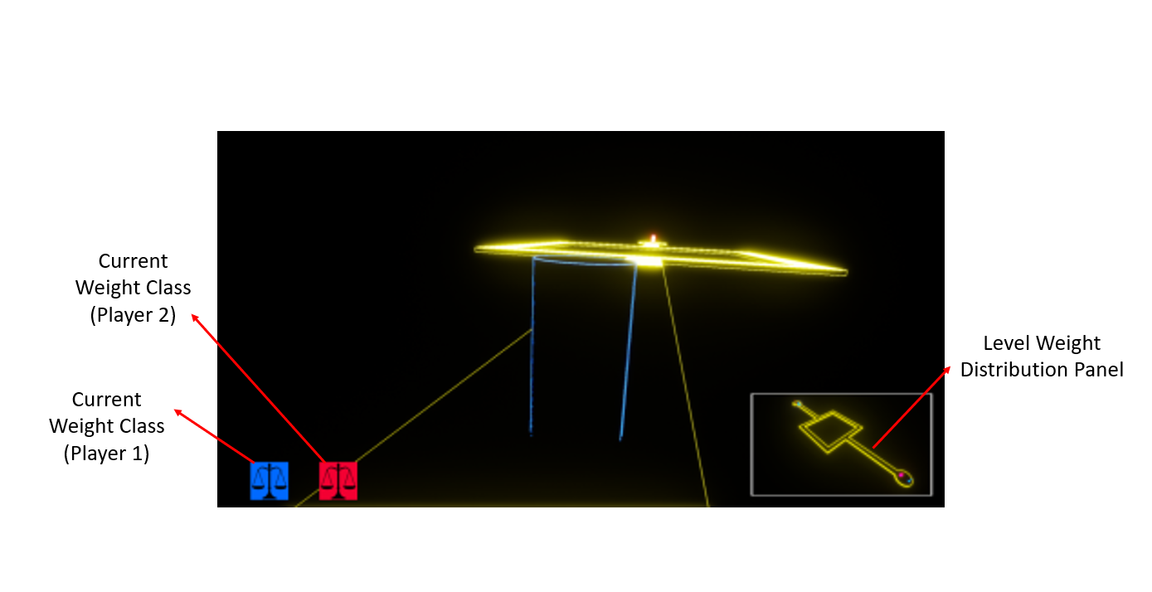

In Game UI (mockup)

## 

## 

## 3.3. Computer Graphics

### 3.3.1. Lighting

The Environment is using Global Lighting. Player characters emit a faint glow of their respective colour. Gameplay items such as weight modifiers, boxes and Buttons also emit a faint glow, meant to highlight their importance on the level. Weight modifiers and boxes have a colour-coded light according to their weight class: lightweight being green, heavyweight being orange and default weight being primary yellow. Buttons have a white glow, and so do the barriers connected to it (if they are enabled), as well as the connecting neon cable.

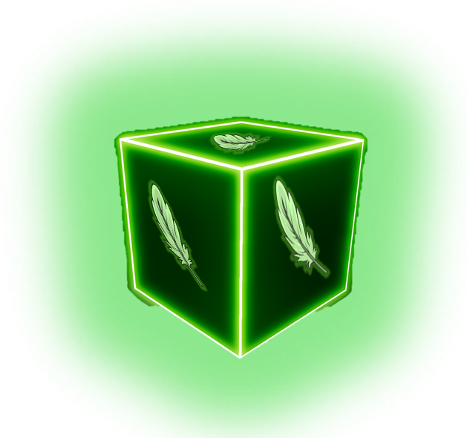

## 

### 3.3.2. Particle effects

The particle effects of Tilted serve to make the game look prettier, as well as provide additional feedback to the player about certain things.

**Neon** - Used in the background and most in-game assets.

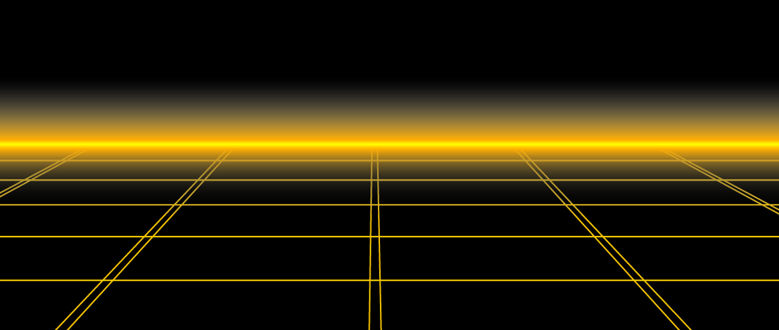

## 3.3.3. Shaders

These shaders are meant to serve gameplay purposes or enhance the game world’s environment.

**Highlight Outline** - Shader outlines the silhouette of an object or character, and can be seen through solid objects like walls. In-game, it’s used to highlight the player’s teammate and the assigned objective.

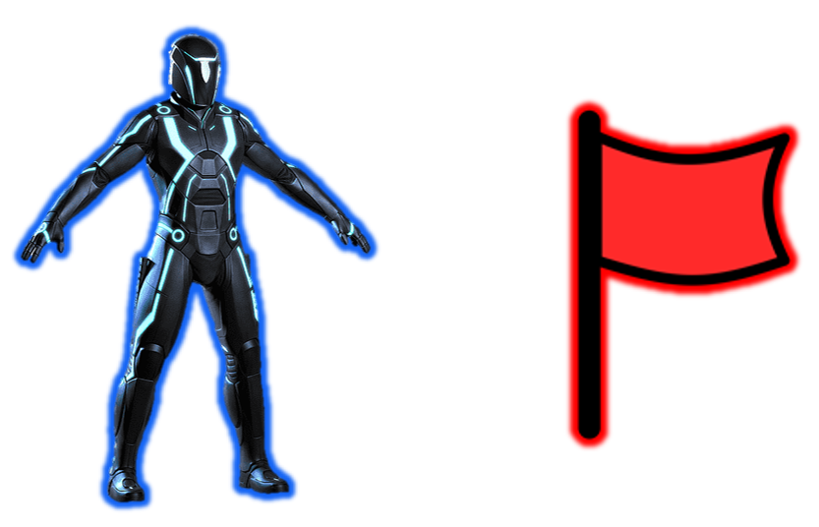

## 

## 3.4. Audio

### 3.4.1. Music

The main menu will have background music, which plays on a loop until the player leaves the menu.

Every level has the same ambient music playing in a loop in the background.

### 3.4.2. Sound effects

Level sound effects:

* **Button** - Buttons make a clicking noise when they are activated.
* **Weight Modifier** - A sci-fi sound plays when a player collects a modifier.
* **Level Complete** - A short, triumphant jingle plays when a level is completed.
* **Level Failed** - A short, not-so-triumphant jingle plays when a level is failed.